**Website on Vighnaan Library**

**REPORT**

**Kalvakota Rohith**

**Suyash Gadiwan**

**Narsee Monjee Institute of Management Studies**

**Shirpur, Maharashtra,**

**India**

**October 12, 2019**

All pages on the website have header division common. It consists of the logo and name of the library and links to popular social media pages like Twitter, Facebook and Instagram.

There is also a navigation bar which consists of links to all the pages.

1. HOME PAGE

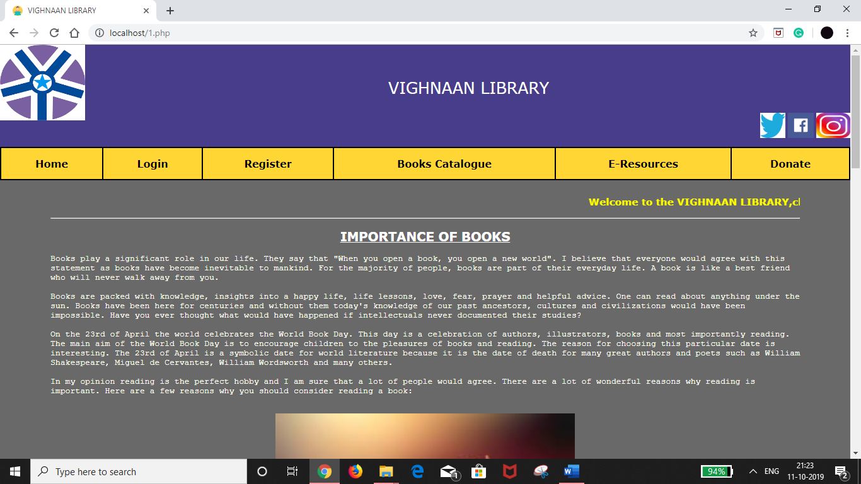

Home page consists of a brief description on Importance of Books along with a map embedded using <iframe> tag.

1. LOGIN PAGE

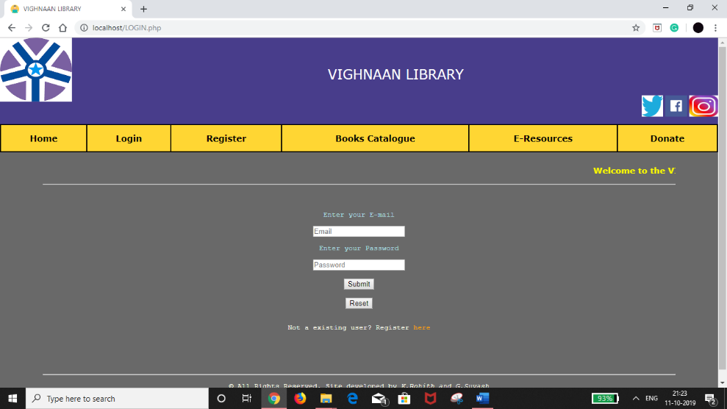

The login page is a typical login page which enforces the user to enter the registered E-mail and password.

If successful, then user is logged in else the user is not logged in and is asked to register.

1. REGISTER PAGE

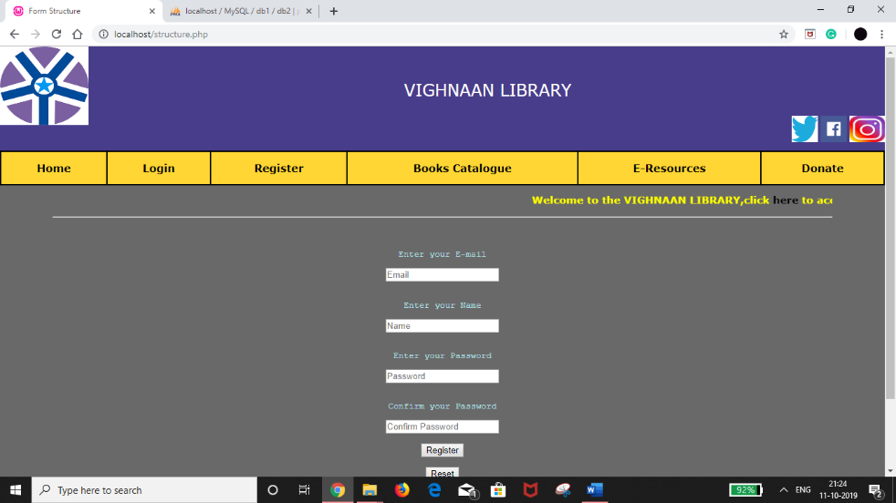

The register page allows any new user to create an account if they provide their name appropriate E-mail and password.

The user cannot register if he/she is using an E-mail ID which has already been registered.

In first case, after successful registration, link has been provided to back to home page.

In second case, links have been provided to retry registration, login or go back to home page.

1. BOOKS CATALOGUE

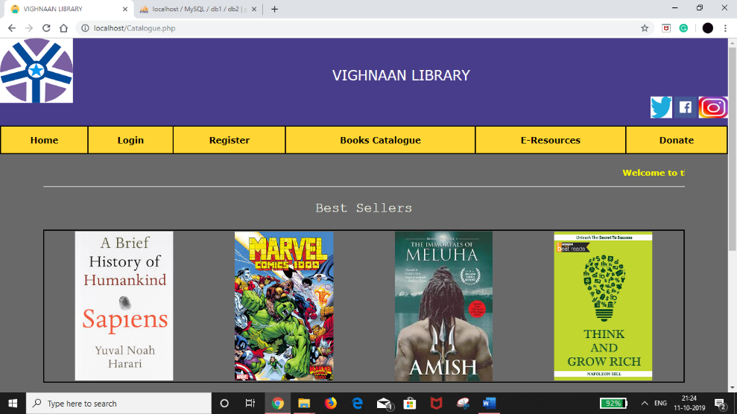

Catalogue page displays the books available with the library.This page allows the user to view the available books in the library present for the user.

1. E-RESOURCES

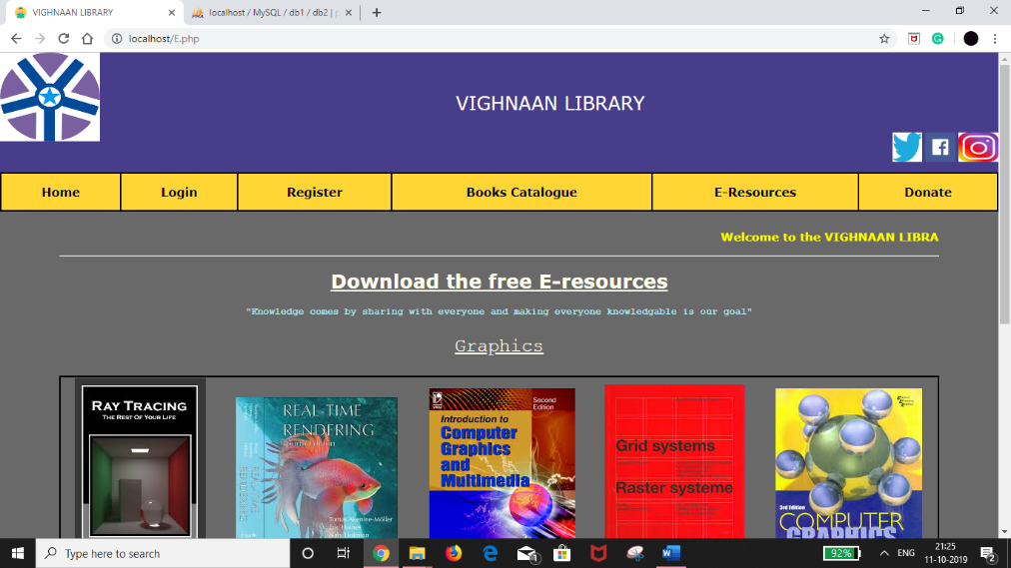

This page on E-resources provides links to download a few books on ‘Graphics’ and resources on subjects like Math, Physics, Chemistry, Biology, Economics and Psychology.

There is also an option to upload resources onto the website which will be then uploaded to the folder which is present on the server.

1. DONATE PAGE

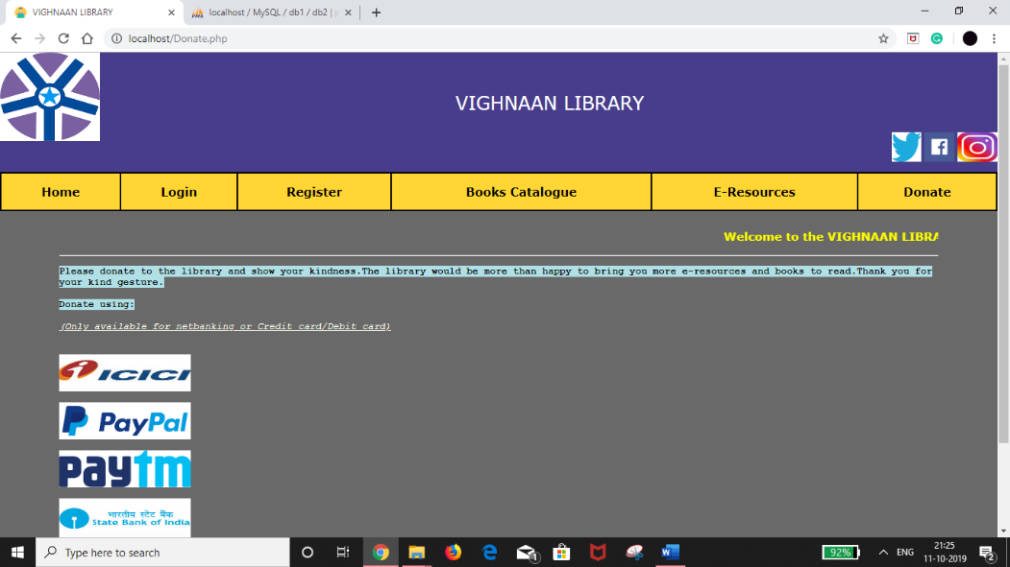

This page has links to a few banks and online payment sites for donation to the library.

LANGUAGES USED-

1. HTML
2. CSS
3. JAVASCRIPT
4. PHP
5. MYSQL